This is the starting page of the task ,by giving valid information and by clicking on submit it redirects to another page

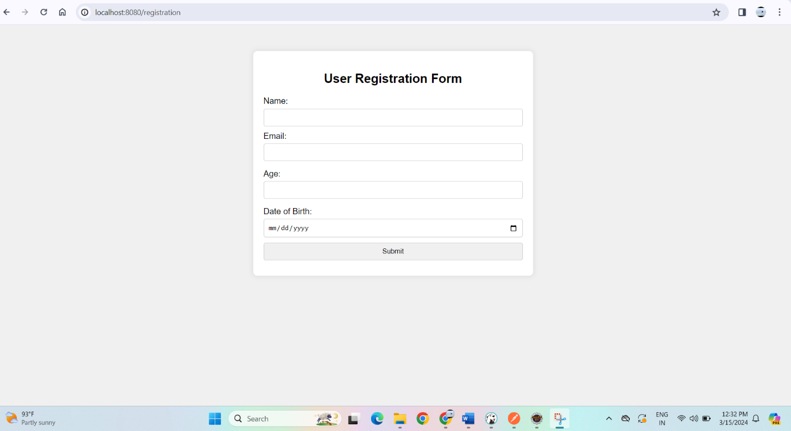

it checks the all validataions,if there is any thing not filled then it gives alert message saying that the field is requried to fill.

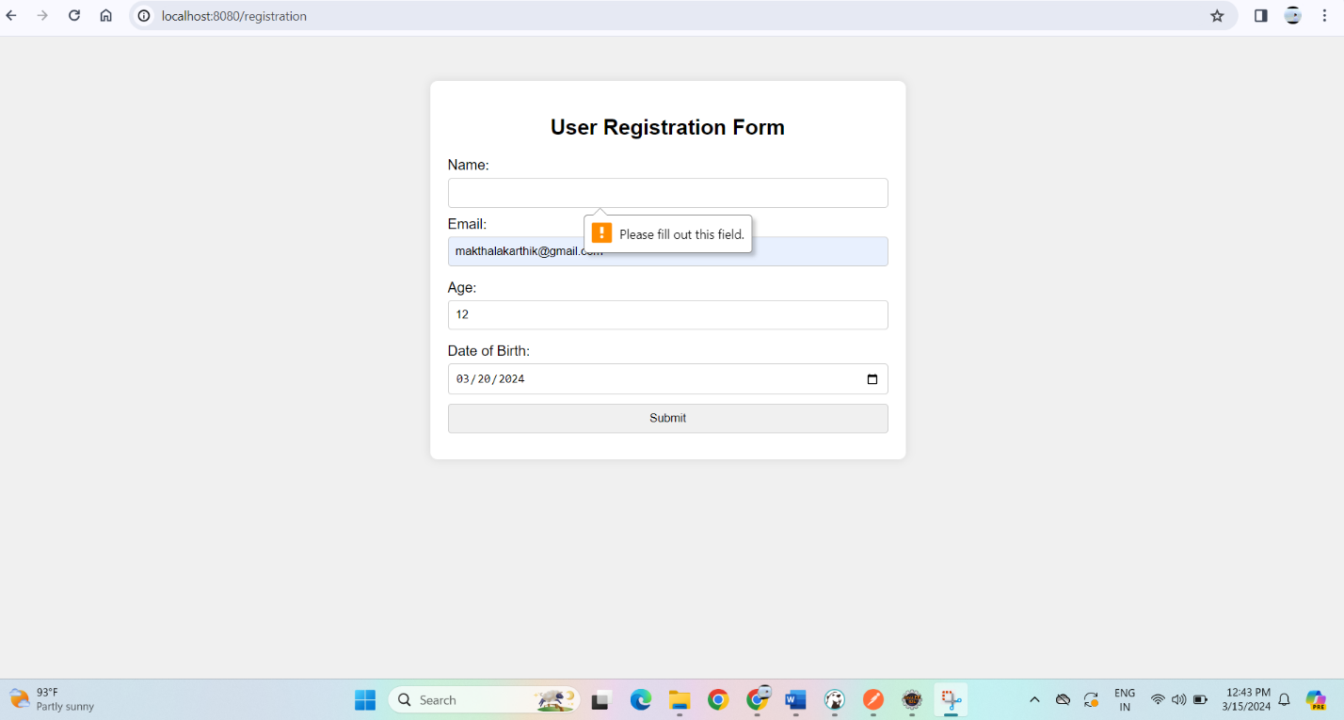

If all the fields are valid then it redirects to this page it contains two types of landing pages ,

It is a successful page which says that registration is successful

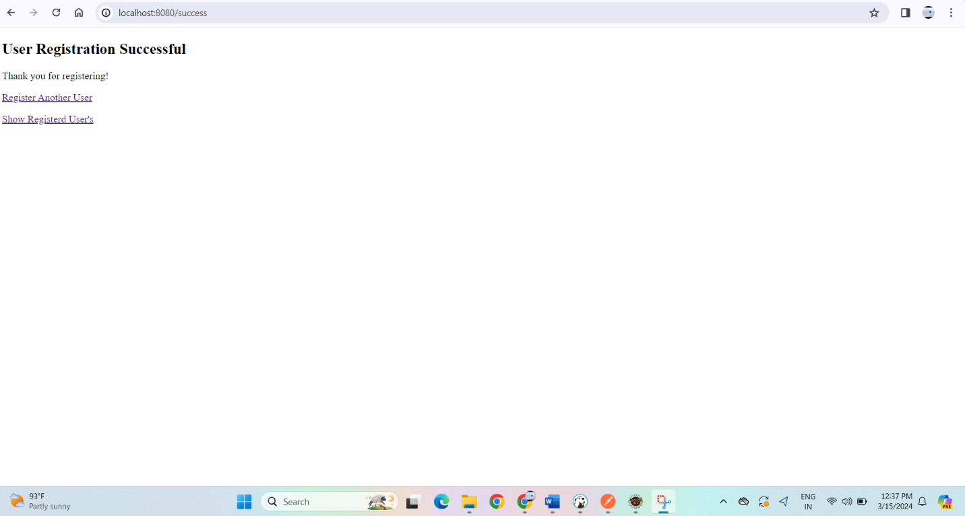

Then by clicking on **register Another user** ,it will redirect to registration form page which is first page .

Then by clicking on **show registered user** ,it will redirect to all registered details

